Marvel's Avengers is a 2020 action role-playing brawler video game developed by Crystal Dynamics and published by Square Enix's European subsidiary.

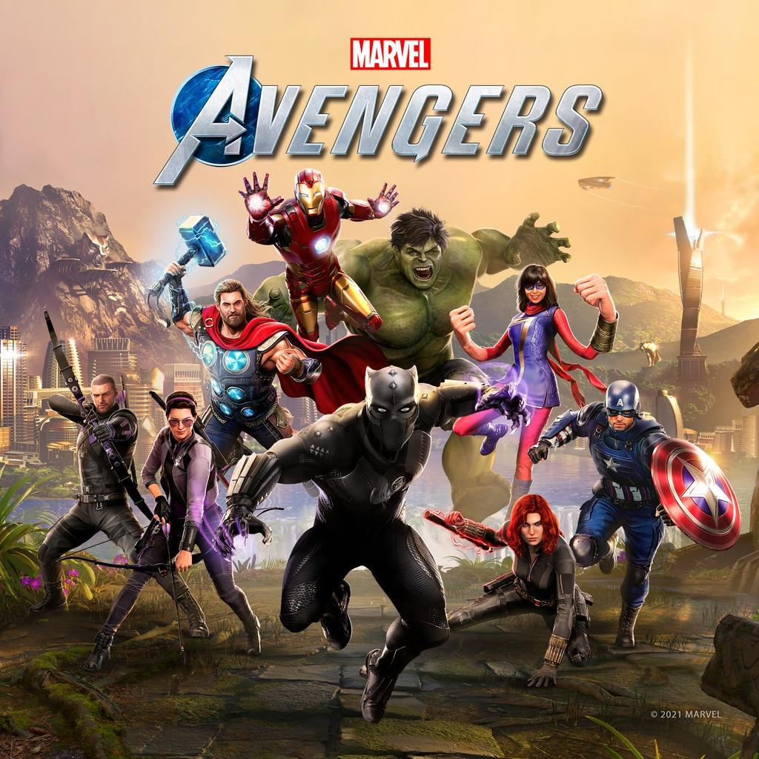

**DEVELOPER:** Crystal Dynamics

**PUBLISHER:** Square Enix

**SERIES:** *An original Cinematic Story*

**GENRES:**Action, third-person, adventure, Brawler

**RELEASE DATE(S)**:US: Sep, 22, 2021

**NUMBER OF PLAYERS:** 1 player for story campaign,1-4 for Avengers Initiative

**Gameplay**

Marvel's Avengers is a third-person, action-adventure game that combines an original, cinematic story with single-player and co-operative gameplay. The game features a unique combat system chaining attacks, dodges, abilities, skills and elements to succeed a combat phase.

The game can be played offline as a single-player experience or online with up to four people during certain aspects of the game. The game will feature customization options including abilities and costumes, which can be upgraded using a skill tree. Costumes have been sourced from "all corners of the Marvel universe" and can be earned in-game or bought separately as DLC. Players will also be able to receive free updates containing new regions and characters.

By this information, I think I can accomplish the software process, because this needs very intricate detailing to the artwork, and picture display. Mostly, CD use AutoDesk ScaleForm.